в 5 «Д» классе

"The Adventures of Tom Sawyer"

Провела: учитель английского языка

Саидова У.А.

г.Кизляр 2020г

Открытый урок английского языка в 5 "Д" классе на тему "The Adventures of Tom Sawyer"

**Цели урока:**

1. **Образовательные:** совершенствовать умение говорить по теме в монологической и диалогической речи, умения аудирования, систематизировать учебный материал;
2. **Развивающие:** развивать логическое мышление, творческую мыслительную деятельность, наблюдательность, кругозор, память учащихся, артистические способности, умение работать с книгой, развивать интерес к культуре других народов;
3. **Воспитательные:** воспитывать честность, смелость, доброту, чувство товарищества и взаимопомощи, внимательное отношение друг к другу, умение прислушиваться к мнению одноклассников, поддерживать интерес к чтению.

**Этапы урока:**

1. Организация класса.
2. Подготовка учащихся к работе на основном этапе урока: мотивация, целеполагание, психологический настрой. Аудирование
3. Работа над содержанием книги: Аудирование, портретная характеристика героев, викторина
4. Работа над образом Тома Сойера. Подбираем синонимы. Групповые задания
5. Закрепление. Метод Диктоглосс
6. Домашнее задание. По ролям( разыграть сценку)
7. Рефлексия групповой работы.
8. Информация о домашнем задании.

**Формы организации познавательной деятельности:**

- парная;  
- групповая;  
- индивидуальная;  
- коллективная.

**Оборудование урока:**

- мультимедийный проектор;  
- компьютер;  
- записи музыки в стили кантри;  
- портрет М.Твена;  
- карточки – задания;  
- выставка книг М.Твена;   
- костюмы для детей;  
- ладошки из цветной бумаги для рефлексии;  
- Цитаты: “Слово, добытое обманным путем, скоро становится тяжелым бременем” М.Твен. “Совесть человека высший суд” В.Гюго.;  
- пословицы на английском языке.

**Технологические особенности урока:** проектный урок в системе развивающего обучения.

**Ход урока**

**I этап.**Организация класса.

Glad to see you! Sit down, please.

Do you like to read? How do you think reading is fun or boring? Do you like to read about someone's adventures? Do you know English children's authors or their books?

How do you think, about what book we will talk today? I'll give you some clues (показываю наводящие картинки)

Yes, you are right. This is a portrait of famous American humorist Mark Twain. And what is his most famous book?

Yes, you are right. It’s ’’The Adventures of Tom Sawyer’’. Our lesson is devoted to Mark Twain and his book. Are you ready for the lesson? lets make a team.

([Слайд 1](https://urok.1sept.ru/%D1%81%D1%82%D0%B0%D1%82%D1%8C%D0%B8/525004/pril3.ppt)).

At the end of the lesson you’ll get a marks on. How are you children? Let’s start our lesson.

**II этап.** Подготовка учащихся к работе на основном этапе урока. Мотивация. Целеполагание.Аудирование ([Слайд 2](https://urok.1sept.ru/%D1%81%D1%82%D0%B0%D1%82%D1%8C%D0%B8/525004/pril3.ppt))

Now let's listen the author's biography .

But first we need to know more about the author. And our lesson we start with audition. The text is about M/T. life and you try to hear as more information as you can.

And then, we will do some quiz.

Оk, you have heard some facts about the author's life, now let's try to ask some questions. I have the cards with the questions about M.T. life. One answer-one point.

**III этап.**  Портретная хар-ка героев([Слайд 7, 9](https://urok.1sept.ru/%D1%81%D1%82%D0%B0%D1%82%D1%8C%D0%B8/525004/pril3.ppt)).

I will describe some characters from the book, and you try to guess, who is it.

Аудирование на английском языке “Узнай героя”.

He is a boy with ideas. He goes to school, but he hates it. He likes to play, he knows many interesting games. His best friends are Huck and Joe. He has no mother and father, but he has got an aunt. What is his name? *(Tom Sawyer)*

2.

She is neither very small nor very tall. Her hair is grey. She wears a dark dress. She takes care about her house and her family.

Her hobby is cooking. She does not go to school. I think she loves Tom very much and Tom loves her.

What is her name? *(Aunt Polly)*

3.

She has a father and a mother. She lives in a big house.

She goes to school every day. She can read and write.

She is little. She has a round face. Her eyes are large and blue. Her hair is long. She wears a nice dress.

She is a beautiful girl.

Who is she? What is her name?*(Becky Thacher)*

*(Yes, you are right. That's all. Thank you. The main characters of the book are...)*

в) чтение текста

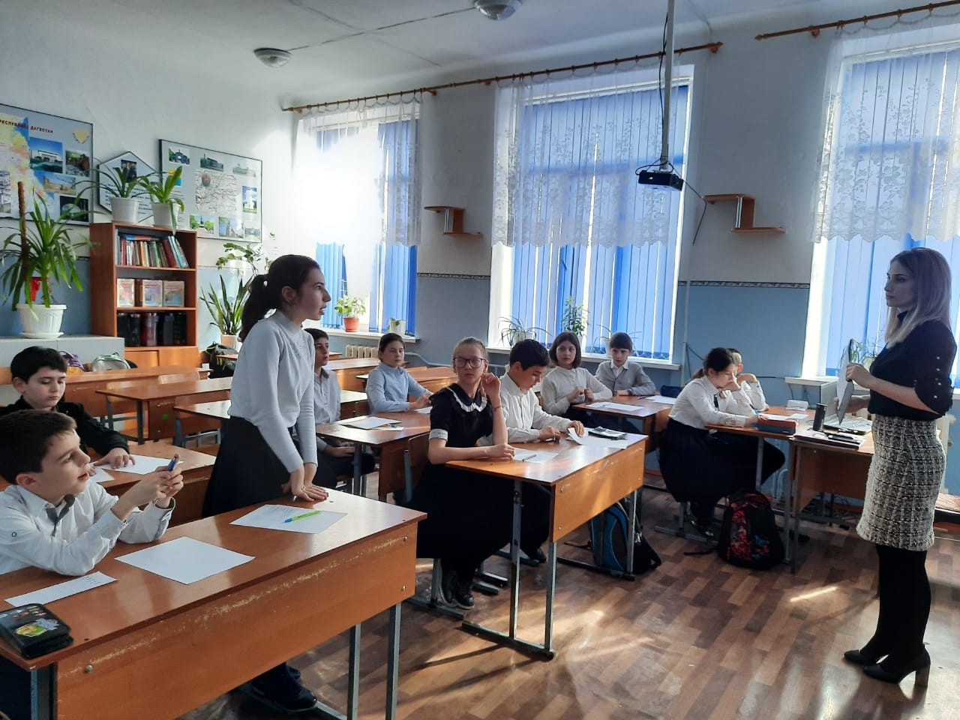

**IV Физкультминутка** *(музыкальная пауза на английском языке. Step! Step! Clap! Clap!)* ([Слайд 15](https://urok.1sept.ru/%D1%81%D1%82%D0%B0%D1%82%D1%8C%D0%B8/525004/pril3.ppt)).

**V этап.** Работа над образом Тома Сойера. Блиц опрос. Групповое задание *(из литературы)*. Кто же такой Том Сойер. Подбираем синонимы([Слайд 16](https://urok.1sept.ru/%D1%81%D1%82%D0%B0%D1%82%D1%8C%D0%B8/525004/pril3.ppt))

We talked about Tom, Huck, Backy and other main heroes, but now we need to compare them .

We'll try to find some differences between them or similarity. But first we need to practice with the words? Consistency is the key. Even when you learning new words you can’t just learn them once and magically to keep inside your head

And don’t just write the words down, go deeper. If it the noun, learn whether it’s countable or uncountable, learn the prefixes and suffixes’, learn synonyms, antonyms.

For example the word “Kind” – good, warm-hearted, generous, gentle, caring, friendly etc. Hateful, cold, unkind, unfriendly. There are so many options.

* When you do learn new words, don’t learn them on their own! Learn them with the words they are often used with.

These are called **Collocations**

Two or more English words often used together

**A party – throw, have, plan** **(not make a party)**

Or instead of memorizing the word learn the phrase

**“Apply”- for a job, for citizenship, for a visa.**

That’s sounds correct and natural when we learn the words in a groups

Lets make warming out- f.e the word 'kind' 'sad' 'happy' give the synonyms and antonyms , then use some prefixes, suffixes.

Давайте, определим главную черту Тома. Для этого мы проведем игру. Let’s play, will you! I’ll give you some cards you must describe Tom Sawyer. *(звучит музыка)*. Are you ready…? Begin, will you! *(на доске плакат Тома Сойера. Дети выходят к доске и приклеивают слова)*. Его характеристика получилась хорошая, но все-таки не исчерпывающая, и мы вместе дополним ее. Давайте вспомним как началось наше знакомство с Томом. *(звучит музыка)*

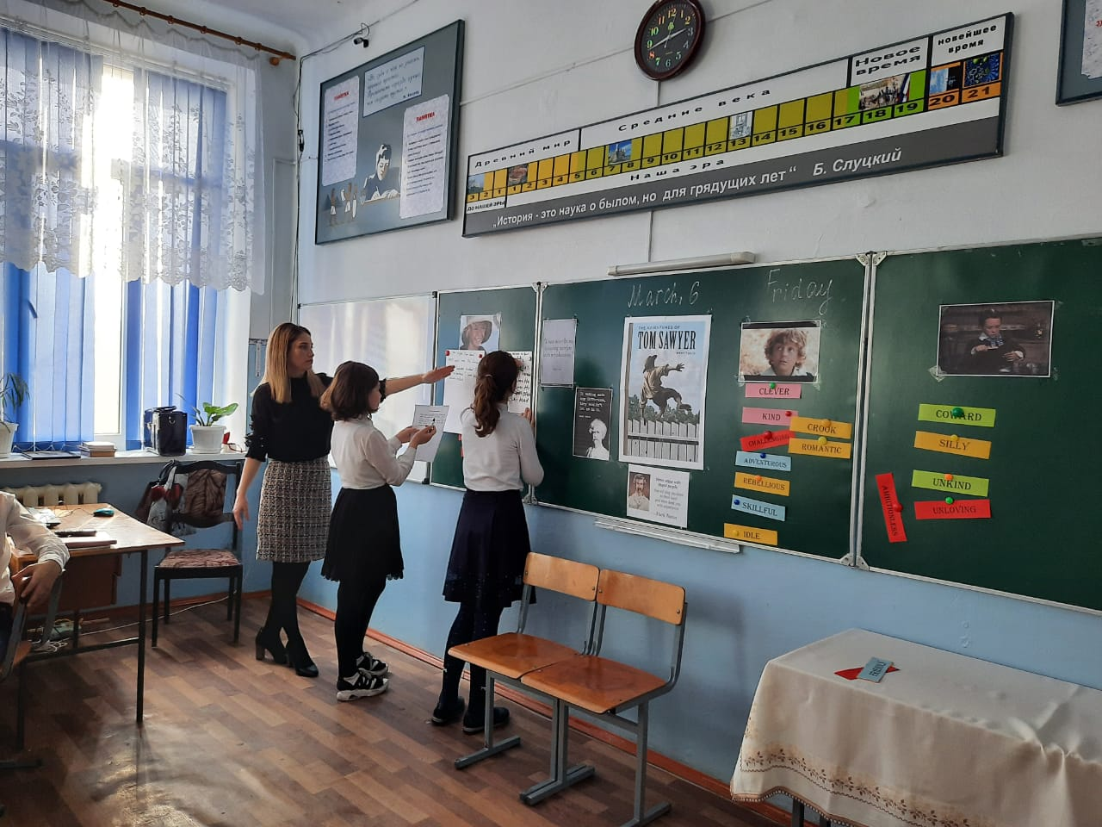

**VI этап.** Метод Диктоглосс. Практика

Listening is important. Collaboration is important. Writing is important.  
Dictoglosses combine all of these things to keep your brains working in a foreign language.  
**What is a dictogloss?**The teacher reads a text. Students listen. They do not take notes. They just listen.

1. The students INDIVIDUALLY write down as much of the story as they can remember. They can use pictures, abbreviations, other words, blanks or anything else that will help them if they don't recall the specifics.
2. (optional) The text is read again. Students do NOT write while the teacher is speaking. When the teacher finishes, they make changes as needed to their version.
3. The students pair up with a friend and together try to combine their versions to get the version as close to the original as possible.
4. Students put down their pens and the teacher reads the text one last time.
5. The students get a few more moments to write their final version (if you as a teacher want you can combine pairs at this point to make a group of 4 working together on the final version).
6. If you want you can have the students write the final version on butcher paper and everyone posts it on the board. Then give students time to circulate and mark any mistakes they see (misspelled words, bad punctuation etc.) I find the faster way is to have them pass the paper to the right/left and then the teacher reads the reading again and they correct the paper.

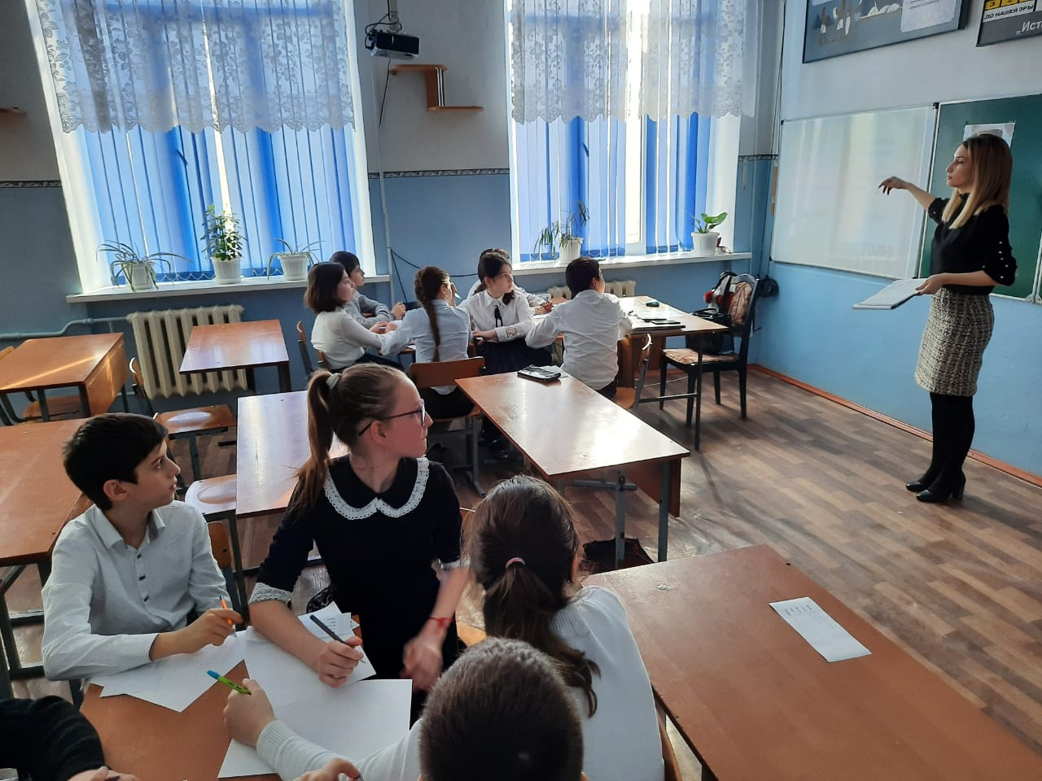

**VII этап.** Домашнее задание - разыграй сценку

([Слайд 21](https://urok.1sept.ru/%D1%81%D1%82%D0%B0%D1%82%D1%8C%D0%B8/525004/pril3.ppt))

**VIII этап.** итоги урока

Когда я перевернула последнюю страницу, то я вспомнила английские пословицы.

All is well, that ends well.

You know a man by his friends.

**IX этап.** Домашнее задание. ([Слайд 24](https://urok.1sept.ru/%D1%81%D1%82%D0%B0%D1%82%D1%8C%D0%B8/525004/pril3.ppt))

**X этап Рефлексия.**

Did you like our lesson?

Did you like heroes?

Would you like to have such faithful friends?

And now come up to the blackboard and fasten your palms to him.

Дети подходят к доске и протягивают “руку дружбы” Тому Сойеру.

The lesson is over. Bye! Bye!

