Постановка сказки Льюиса Кэрролла

на английском языке
В 7-ых классах
11.04.2019г
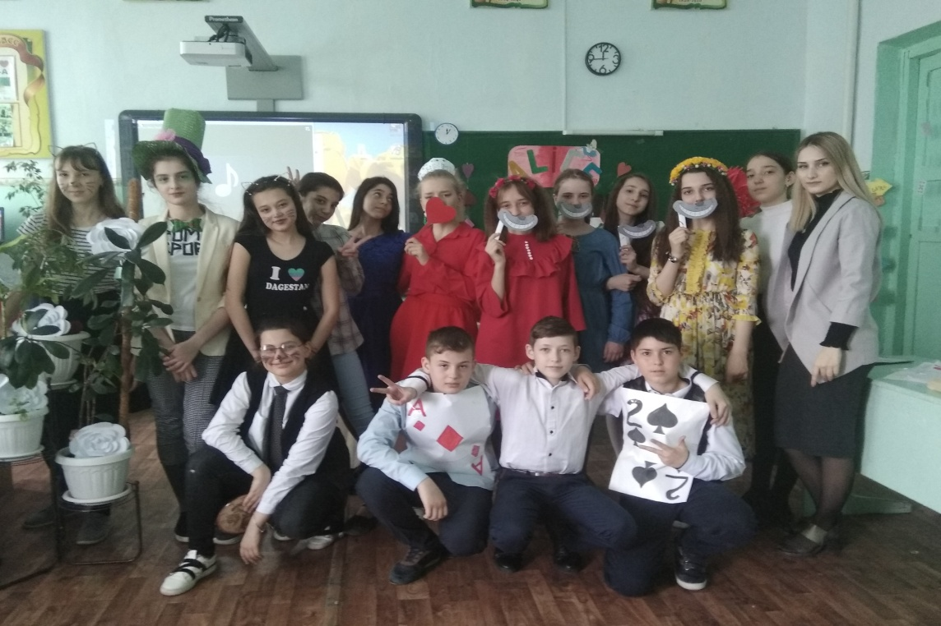
Провела: учитель Английского языка
Саидова У.А.

«Алиса в стране чудес»

Цели внеклассного мероприятия:

практическая – дальнейшее развитие навыков говорения (монолог, диалог), развитие навыков аудирования;

образовательная–приобретение знаний о писателе, литературном произведении и сказочных героях страны изучаемого языка;

воспитательная–воспитывать интерес к традициям Великобритании,

воспитыватьуважение к культуре, литературе и искусству других народов и стран, прививать любовь и интерес к английскому языку.

Оборудование: презентация, иллюстративная наглядность, аудиозаписи, реквизит.

Ход мероприятия:

1. Организационный момент.
Teacher: Good morning, dear students and our guests. Today we are going to talk about the British writer Lewis Carroll and his famous work “Alice's Adventures in Wonderland”. We will learn about Carroll’s life and about his eternal book. Students of the seventh form will bring you into the world of adventures and fairy-tale for a short time.

SCENE 1
(Alice is sitting and reading a book.)

Alice: It is so boring! What is the use of a book without pictures or conversations? (зевает) If I make a daisy-chain… Would it be worth trouble of getting up and picking the flowers? (засыпает)
(пробегает кролик)

SCENE 2
Rabbit: Oh my whiskers and ears! How late it’s getting!

Alice: Hello! Hello! Anyone there? (finds a bottle “Drink me”, drinks) It’s only a dream.(becomes small). I am opening like the biggest telescope ever! Good-bye, feet!
Alice: That’s curious. If this is the prank, I’m not amused. (eats the cake “Eat me”) I must be shutting up like a telescope! Curiouser and curiouser. (sees the flowers) Excuse me, could you… Oh, that’s nonsense, flowers can’t talk.

Flowers: Of course we can. We can tell you a story.

Flower 2: Let’s tell her about tulips.

Flower 3: Oh, no. Violets – she’d like them better.

Flower 4: What about daisies?

Flower 5: Girls, stop arguing, let’s dance. It’s about all of us.

(dance)
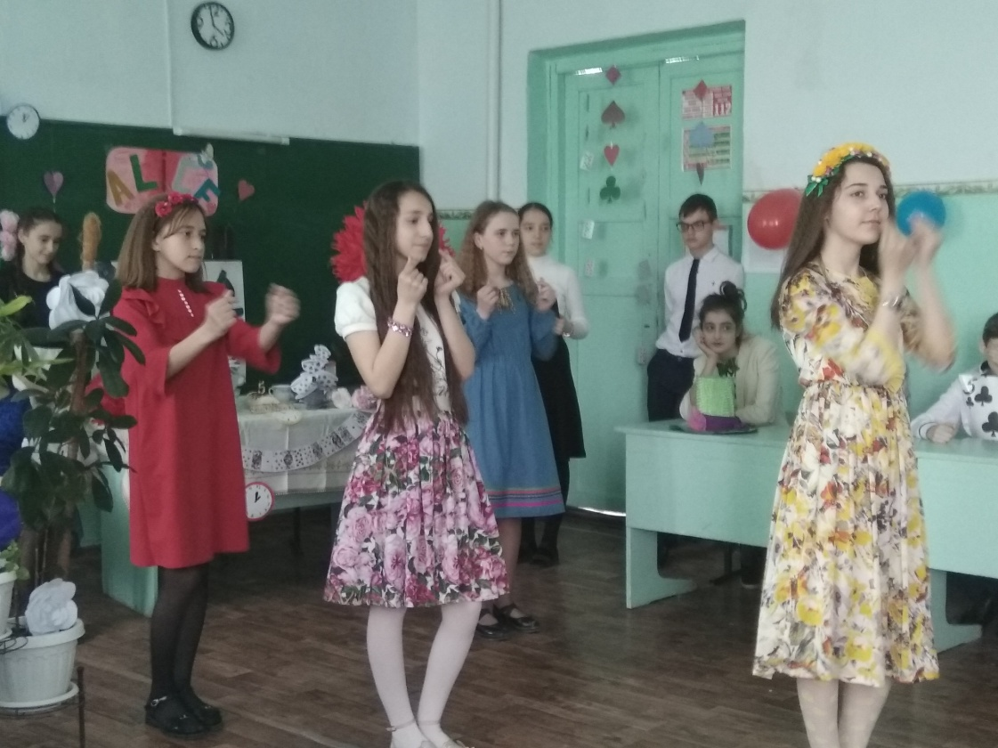

Alice: Thank you, my dear. I wish I could be just like you.

Flower 4: We are pretty.

Flower 3: We are great.

Flower 2: And you are not from our garden.

Flower 1: For what did you come?

Alice: I didn’t come for your garden.

Flower 2: Is she a wild flower?

Alice: Oh, no, I’m not a flower.

Flower 3: Just what species or, shall we say, genes.

Alice: I don’t know what genes humans are. I’m a little girl.

Flower 1: Violets, she said she’s just a little girl.

All flowers: Ee-ooo.

Alice: I’m not a flower.

Flower: Aha! She is a common weed.

Alice: I’m not a weed!

Flower: Well, you wouldn’t expect her to admit it.

Flower: Whatever.

Alice: Stop talking to me like that! It’s my dream!

Flower: But you are in our garden.

Flower 1:Oh, and isn’t it from petals?

Flower: And no fragrance.

Flower: Girls, she might have bugs.

All flowers: Ee-ooo.

Alice: If I were my right size, I could pick every one of you if I wanted to! And I'd guess that would teach you! Oh, they make me so mad! They call me a weed, because I am as small as a snail. I should find someone normal if I want to get back home.

SCENE 3
CHASHIRE CAT

Alice: And now where shall I go?

(cartoon)

Alice: Goodness! If the people here are like that I must try not to upset them.

SCENE 4
Mad Tea Party

(Hatter, Dormouse, March Hare, dancing and jumping)

All: A very merry unbirthday to us, to us!
A very merry unbirthday to us, to us!

March Hare: A very merry unbirthday to me!

Hatter: To who?

March Hare: To me!

Hatter: Oh you!

March Hare: A very merry unbirthday to you!

Hatter: Who, me?

March Hare: Yes, you!

Hatter: Oh, me!

March Hare: Let's all congratulate us with another cup of tea
A very merry unbirthday to you!

Hatter: To me!

(sitting at the table, Dormouse falling asleep)
(Alice is going to join the party)

March Hare & Mad Hatter: No room, no room, no room, no room, no room, no room, no room!

Alice: But I thought there was plenty of room!

March Hare: Ah, but it's very rude to sit down without being invited!

Mad Hatter: I say it's rude. Its very very rude, indeed!

Dormouse: Very very very rude, indeed...

Alice: Oh, I'm very sorry, but I did enjoy your singing and I wondered if you could tell me...

March Hare: You enjoyed our singing?

Mad Hatter: Oh, what a delightful child! Hah! I'm so excited, we never get compliments! You must have a cup of tea!

March Hare: Ah, yes indeed! The tea, you must have a cup of tea!

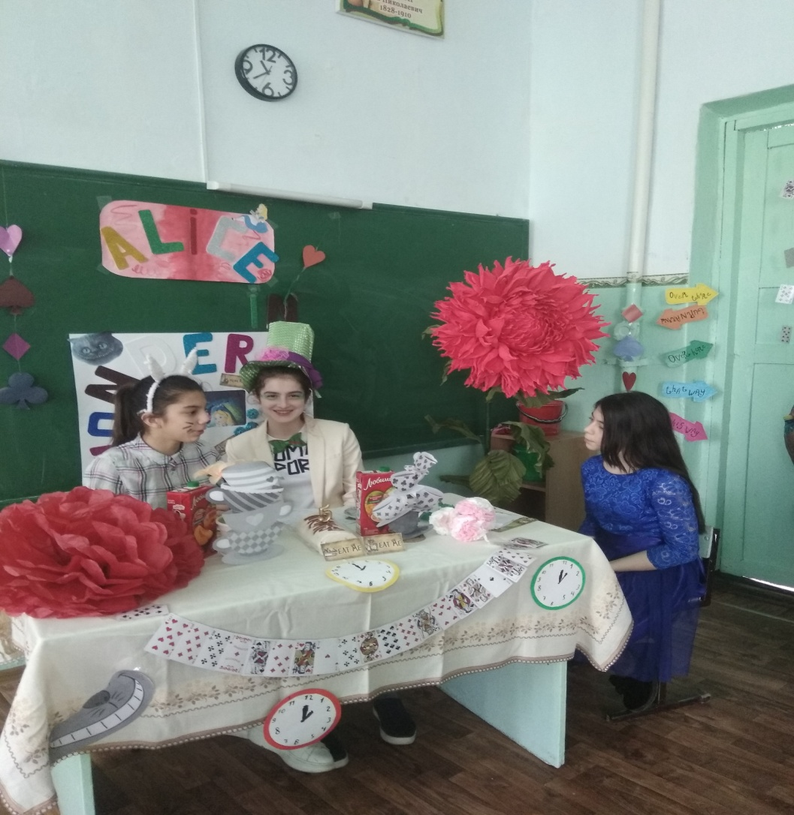

Alice: That would be very nice. I'm sorry I interrupted your birthday party... uh, thank you.

March Hare: Birthday? Hahaha! My dear child, this is not a birthday party!

Mad Hatter: Of course not! Hehehe! This is an unbirthday party!

Alice: Unbirthday? Why, I'm sorry, but I don't quite understand.

March Hare: Its very simple. Now, thirty days have sept- no, when... an unbirthday, if you have a birthday then you... haha... she doesn't know what an unbirthday is!

Mad Hatter: How silly! Ha ha ha ha! Ah-hum... Now statistics prove, prove that you've one birthday.

March Hare: Imagine, just one birthday every year.

Mad Hatter: Ahhh, but there are 364 unbirthdays!

March Hare: Precisely why we're gathered here to cheer!

Alice: Why, then today is my unbirthday too!

March Hare: It is?

Mad Hatter: What a small world this is.

March Hare: In that case... a very merry unbirthday.

Alice: To me?

Mad Hatter: To you!

March Hare: A very merry unbirthday.

Alice: For me?

Mad Hatter: For you! Now blow the candle out, my dear and make your wish come true!Hihihi!

March Hare & Mad hatter: A very merry unbirthday to you!

Alice: Oh, that was lovely!

Mad Hatter: And uh, and now my dear, hehe, uh... you were saying that you would like to sea.. uh...? You were seaking some information some kind... hehe!

Alice: Oh, yes. You see, I'm looking for a...

Mad Hatter: Clean cup, clean cup! Move down!

Alice: But I haven't used my cup!

Mad Hatter: Would you like a little more tea?

Alice: Well, I haven't had any yet, so I can't very well take more...

Alice: But I only meant that...

White Rabbit: Oh, I'm so late! I'm so very very late!

Mad Hatter: Well, no wonder you're late! Why, this clock is exactly two days slow!

White Rabbit: Two days slow?

Mad Hatter: Of course you're late. Hahaha! My goodness. We'll have to look into this. A-ha! I see what's wrong with it! Why, this watch is full of wheels!

White Rabbit: Oh, my poor watch! Oh, my wheels! My springs! But- but- but- but, but- but- but...

March Hare: Tea?

White Rabbit: No! Not tea!

Alice: Mister Rabbit! Oh, mister Rabbit! Oh, now where did he go to?

March Hare & Mad Hatter: A very merry unbirthday to us, to us. A very merry unbirthday to us, to us...

Alice: Of all the silly nonsense, this is the stupidest tea party I've ever been to in all my life. I'm going home. Straight home.

SCENE 5
Painting the Roses Red

Cards: Painting the roses red
We're painting the roses red
We dare not stop
Or waste a drop
So let the paint be spread
We're painting the roses red
We're painting the roses red

Oh, painting the roses red
And many a tear we shed
Because we know
They'll cease to grow
In fact, they'll soon be dead
And yet we go ahead
Painting the roses red

Painting the roses red
We're painting the roses red
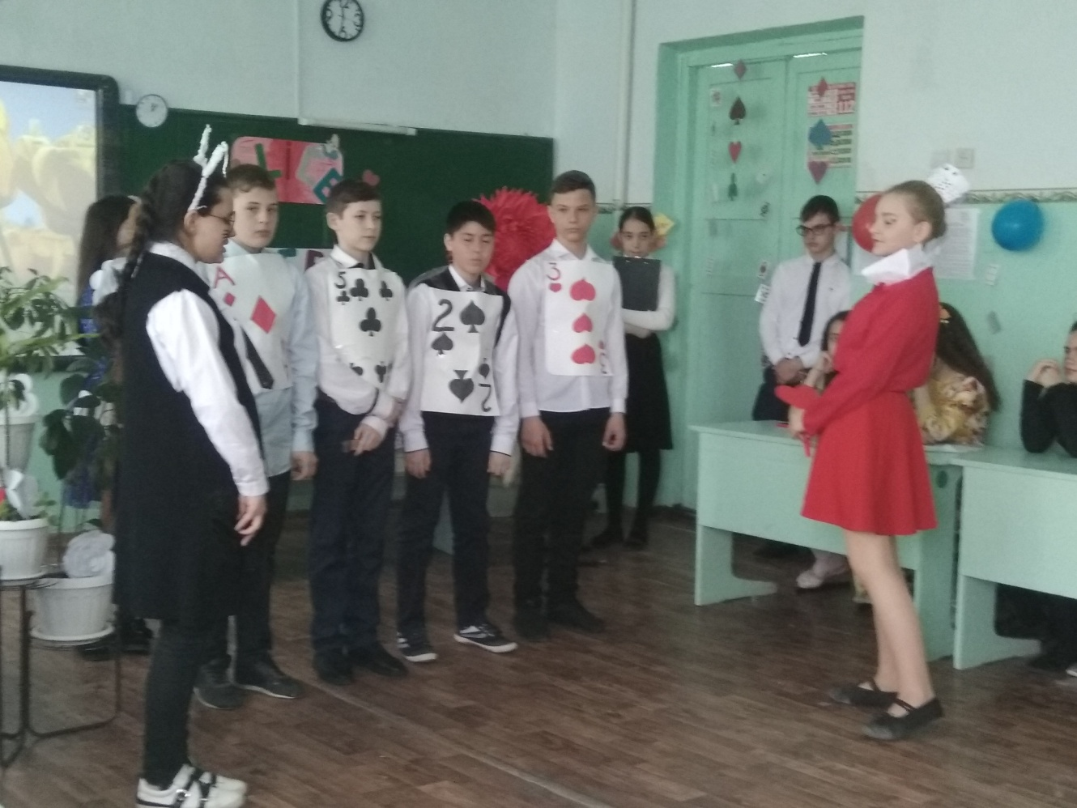
Alice: Oh, pardon me
But Mister Three
Why must you paint them red?

Card 1: Huh? Oh! Well, the fact is, Miss, we planted the white roses by mistake and...

Cards: The Queen she likes 'em red
If she saw white instead
She'd raise a fuss
And each of us
Would quickly lose his head

Alice: Goodness!

Cards: Since this is the part we dread
We're painting the roses red

Alice: Oh, Dear! Then let me help you.

All: Painting the roses red
We're painting the roses red

Cards: Don't tell the Queen what you have seen
Or say that's what we said
But we're painting the roses red
Yes, painting the roses red

Card 1: Not pink

Card 2: Not green

Card 3: Not aquamarine

All: We're painting the roses red!

Card 1: Hush! Silence! The Queen and her cards!!

SCENE 6
Cards and the Queen of Hearts

(dance of the cards)

Cards: The Queen! The Queen!

Alice: The Queen!

Queen: Cards, halt!

Alice: The rabbit!

White Rabbit: He...he... her imperial highness, he... her grace, her excellency, her royal majesty, the Queen of Hearts!

A card: Hurray!
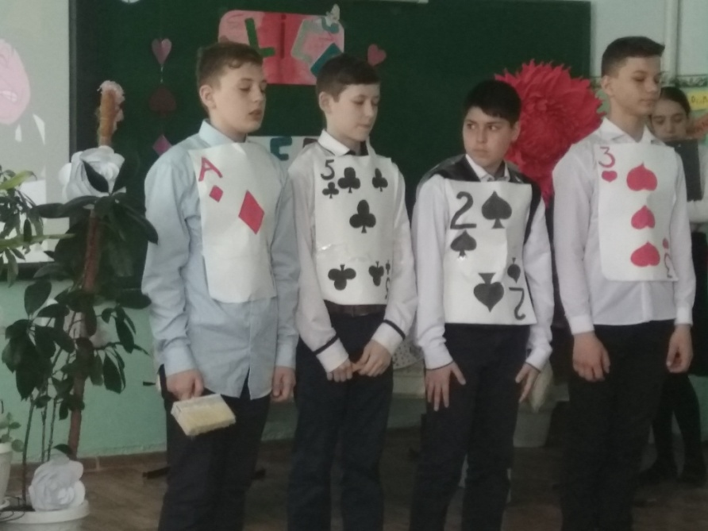

Queen: Hum... Who's been painting my roses red? Who's been painting my roses red? Who dares to taint, with vulgar paint, the royal flower bed? For painting my roses red, someone will loose his head!

Three: Oh, no! Your majesty! Please, it's all his fault!

Two: Not me, your grace! The Ace, the Ace!

Queen: You?

Ace: No, Two!

Queen: The Two you say?

Two: Not me, the Three!

Queen: That's enough! Off with their heads!

Alice: Oh, please, please! They were only trying to...

Queen: And who is this?

Alice: My name is Alice.

Queen: Look up, speak nicely, and don't twiddle your fingers! Turn out your toes. Curtsey. Always say 'yes, your majesty'!

Alice: Yes, your majesty!

Queen: Hm. Now, um, where do you come from, and where are you going?

Alice: Well, um, I'm trying to find my way home...

Queen: Your way? All ways here are my ways!

Alice: Well, yes, I know, but I was just thinking...

Queen: Curtsey while you're thinking, it saves time.

Alice: Yes, your majesty, but I was only going to ask...

Queen: I warn you child, if I loose my temper, you loose your head, understand?

Alice: Oh, pooh. I'm not afraid of you! Why, you're nothing but a pack of cards! And as for you, your majesty! you're not a queen, but just a fat, pompous, bad tempered old tyrant...

Queen: What!!! Off with her head! Off with her head! Off with her head! Don't let her get away!

Misha: Wake up! Wake up!
Alice: Mr Rabbit! It’s you!
Misha: Uliyana, are you OK? (finds the book “Mathematics”). Everything is clear. You should have some rest. What about a cup of tea?

Alice: Oh, no! Not again!

Постановка сказки Льюиса Кэрролла

на английском языке
В 7-ых классах
11.04.2019г
Провела: учитель Английского языка
Саидова У.А.

